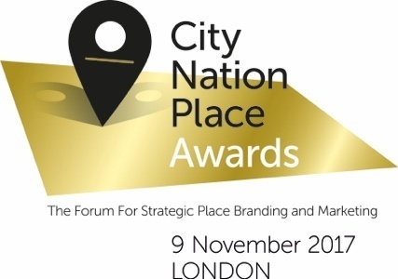
Entry Template

Entry Title [name of individual, company or firm]:

Please select the appropriate Award Category:

Best Expression of Best Place Identity Through Design
Best Citizen Engagement
Best Use of Social Media
Best Communication Strategy
Please use Entry Template B for Place Brand of the Year

Please note, you can of course enter duplicate categories. We would strongly advise that you write separate entries for each category – to give you the best opportunity to highlight why you feel your work should win against each particular category’s criteria.

Your entry:
Section One: The Challenge/background
In no more than 200 words, please set the context for your entry –provide some background for the challenges faced by your place, the thinking behind your place brand strategy objectives and/or the particular opportunities addressed over the past year [1 March 2016 – 30 June 2017]

Section Two: The Strategy
In no more than 300 words, please outline the strategic approach decided upon – the Jury will be keen to understand the thinking behind the strategy, the objectives agreed upon and the reasons for the approach you have taken.
Section Three: The Implementation
In no more than 300 words, please describe how the strategy has been implemented over the past year [1 March 2016 – 30 June 2017]. The Jury will be keen to understand how multiple stakeholders may have been involved, any challenges which were faced and overcome and any lessons you may have learned along the way.

Section Four: The Results
In no more than 200 words, please provide details of the results achieved over the past year [1 March 2016 – 30 June 2017] – the Jury will expect to see that these results relate to your objectives.

When submitting your entry, you will have the opportunity to provide up to three supporting pieces of material. These should not be a lengthier description of your entry, but rather images, or videos, or links to websites, or pdfs of documents used to communicate your strategy etc. which the judges can peruse.

When you are happy with your entry, please go to www.citynationplace.com/awards/how-to-enter to submit your entry. There are no fees for entering. All entries must be submitted before 21 September 2017 to be considered. Shortlisted entries will be announced on 12 October 2017 and the winners will be announced at the City Nation Place conference taking place in London on 9 November 2017.

