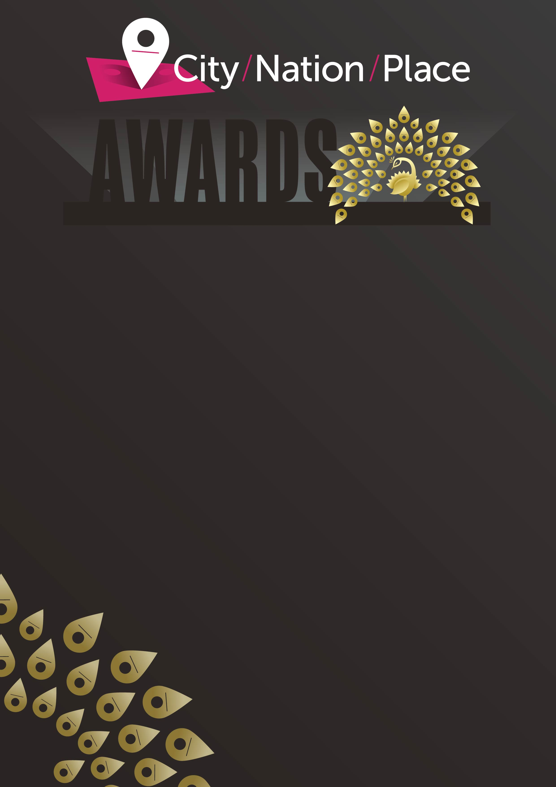

ENTERING DETAILS

Category:
BEST CITIZEN ENGAGEMENT

Entry title:
Click or tap here to enter text.

City, nation, or place this entry relates to:
Click or tap here to enter text.

Entering organisation:
Click or tap here to enter text.

AWARD ENTRY
Section One: The Challenge/background
In no more than 200 words, please set the context for your entry. Provide the background for the challenges or opportunities for your place, why it was so important to engage or re-engage citizens.

Click or tap here to enter text.

Section Two: The Strategy
In no more than 300 words, please outline the strategy you developed to engage citizens. The jury will be keen to understand why you chose a particular approach, channels of communication, and/or tools that you did. They will also want to hear what KPIs you set for your approach.

Click or tap here to enter text.

Section Three: The Implementation
In no more than 300 words, please describe how the strategy was implemented over the qualifying period [1st April 2021 and 31 July 2022]. The jury will be keen to understand any challenges you faced and overcame, and/or any lessons you may have learned along the way.

Click or tap here to enter text.

Section Four: The Results
In no more than 200 words, please provide details of the results achieved. The jury will expect to see that these results relate to your objectives and will be interested to hear how you plan to take this strategy forward.

Click or tap here to enter text.

SUPPORTING EVIDENCE
When submitting your entry, you will have the opportunity to provide up to three supporting pieces of material. These should not be a lengthier description of your entry, but rather images, or videos, or links to websites, or pdfs of documents used to communicate your strategy etc. which the judges can peruse.

All entries need to be submitted HERE at which point a link will be sent to you to pay for each entry.

Please note, entries must be submitted and paid for before 8 September 2022 to be considered. Shortlisted entries will be announced on 6 October 2022 and the winners will be announced at the virtual City Nation Place Global conference on 10 November 2022.

