RRUKA Feasibility Study Proposal

2015

Competition: “Applications of Robotics and Autonomous Systems to Rolling Stock Maintenance”

Insert your proposal title here

Name Lastname, University / other organisation (please repeat for each individual member of the consortium)

Name Lastname, University / other organisation (please repeat for each individual member of the consortium)

Name Lastname, University / other organisation (please repeat for each individual member of the consortium)

Submission date: Click here to enter a date.

Project Description

You can organise this section as you prefer but must include: project scope and objectives; methodology; breakdown of tasks; description of expected deliverables for each task and associated deliverable dates.
Heading 1
Body of text

Heading 2
Body of text

- Bullet1
- Bullet1
- TableTitle

Project Plan

This should be a graphic representation of milestones, activities and deliverable dates. See the Gantt chart example below.
Project commencement date:
Project completion date:

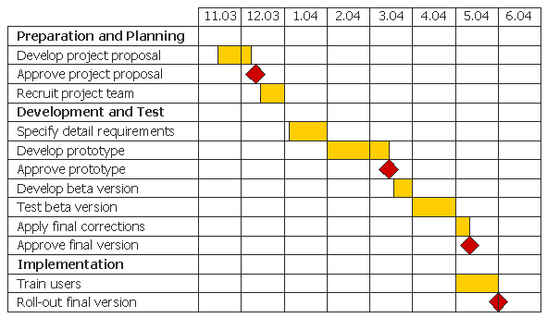

Costing
Please complete the Excel spreadsheet tilted ‘Master Pricing Sheet Grant Funding.xls’.

Next Steps and Benefits

This section should include a description of the ‘next steps’ and associated benefits, should the proposal be successful, including a summary table like the one in the example below.
Body of text

- Next steps
TRL (technology readiness level) | Approx cost | Approx duration | Activities | Potential funding route

Consortium members

This section should include details and a short summary of each individual consortium member’s expertise. Ensure you identify the academic project lead.
Academic members
Body of text

Industry members (if any)
Body of text

Project team contact details:

Name | University / Organisation | Email address
Project Lead
Project team
Project team

Contracts team contact details:
Please enter the contact details for the Contracts team at the lead University.
Name | University | Email address

Lay summary

Please provide us with half-page summary which will be uploaded on SPARK if the proposal is successful.

Grant Agreement
A draft Grant Agreement is available online.

Where the organisation has any queries or concerns with any specific condition/s of the Grant Agreement, these should be submitted by completing the Contract Issues form below. Please detail the specific condition(s) together with your proposed amendment(s). These will be reviewed by RSSB on a case by case basis, and, if accepted, a revised Grant Agreement will be issued.

Failure to accept the conditions of the Grant Agreement or reach a mutual agreement within 20 working days, may result in the grant funding being withdrawn by RSSB.

Conditions of the Grant Agreement the organisation has not objected to in its response may not be subject to negotiation on award of contract.
Section & Clause Number | Section Heading (if applicable) | Reason for required change | Proposed amendment | RSSB response

This is a foot note

